AQUATICS GB

ALLQUATICS

DIVERSITY, EQUITY AND INCLUSION (DEI) REPORT 2024

INTRODUCTION

Aquatics GB plays a pivotal role within the sport’s governing body system, with a steadfast focus on delivering world-class performance. The expectations placed upon us to lead in this area have never been more significant. The 2023 DEI Report provided valuable insights into the themes that Aquatics GB should be known for now and in the future, including fostering a positive influence, demonstrating leadership, setting the standard and driving greater awareness.

Building on this foundation, our 2024 DEI Report reflects a deeper and more comprehensive analysis of our efforts, underpinned by enhanced data and a stronger commitment to transparency and accountability. This report highlights our ongoing progress and the steps we are taking to advance DEI across all areas of Aquatics GB.

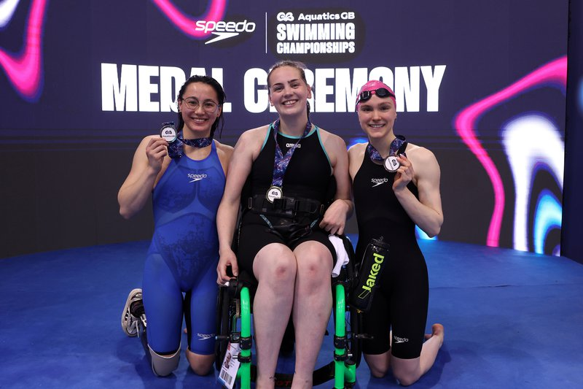

Why We’re Doing It

**Equity Drives Performance**

“We strengthened our ties with communities in major cities around the country”

Last year we took a conscious decision to embed equity across our organisation to ensure we create equitable environments that all individuals, regardless of their background, have the resources they need to succeed. We strengthened our ties with communities in major cities around the country, laying the groundwork for sustained engagement. By focusing on equity over equality, we address individual circumstances to achieve fair outcomes, aligning with our commitment to high performance and organisational growth. Our DEI initiatives aim to attract and retain top talent, foster innovation and enhance the satisfaction of employees and athletes.

### **Inclusivity as a Competitive Advantage**

An inclusive workplace allows every team member to bring their authentic selves to work, creating a positive environment where performance thrives. Commercially, a diverse and inclusive organisation can better reflect the communities we serve and engage with, building long-term success. Aquatics GB's partnerships with local businesses and community organisations have further strengthened our 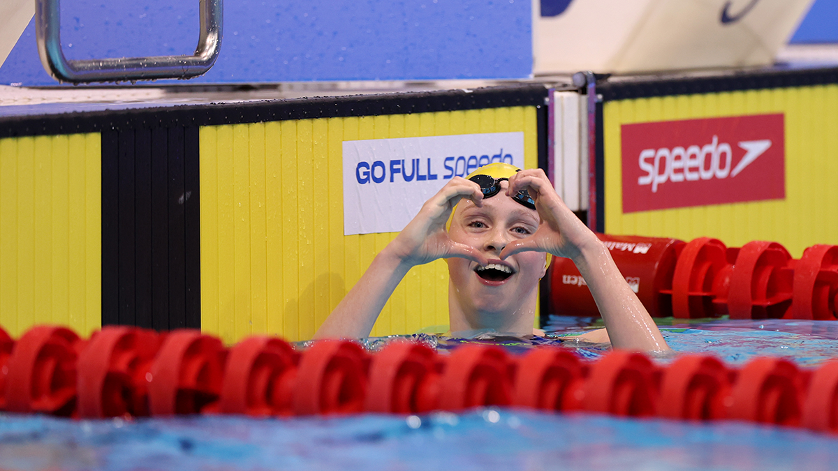ability to reach underrepresented groups, ensuring our programs and initiatives resonate with a wider audience. At the British Swimming Championships in London and British Diving Championships in Birmingham, we continued our commitment to supporting communities throughout the year, not just at our events. This included hosting Pride Swim launch at the London Aquatics Centre, disability swim taster sessions, holiday camp swim sessions for local children in the east London area and diving taster sessions in Sandwell.

**Diversity, Equity and Inclusion Action Plan (DEIAP) 2024-2028**

The Diversity, Equity and Inclusion Action Plan outlines Aquatics GB’s ambitions for progressing DEI across all levels of the organisation. In June 2024 we launched our comprehensive action plan, which set out the organisations direction for DEI to LA 2028. Aquatics GB is proud to be the first National Governing Body to have its new DIAP approved by UK Sport, in line with their Code for Sports Governance. The DEI Action Plan can be found [here](https://www.britishswimming.org/about-us/equality-and-diversity/).

Highlights from 2024

**Enhanced Feedback Opportunities**

For the second year, we provided platforms for detailed feedback through our DEI survey. This year’s survey included demographic insights and in-depth qualitative responses, revealing key themes around leadership diversity, transparency, and communication.

**Increased Representation Data**

Our 2024 survey showed improvements in several areas:

* Representation of employees and athletes identifying as non-white in 2024 was 8.02% (down from almost 10% in 2023). Our athlete representation has maintained level at nearly 10% (9.63%).
* 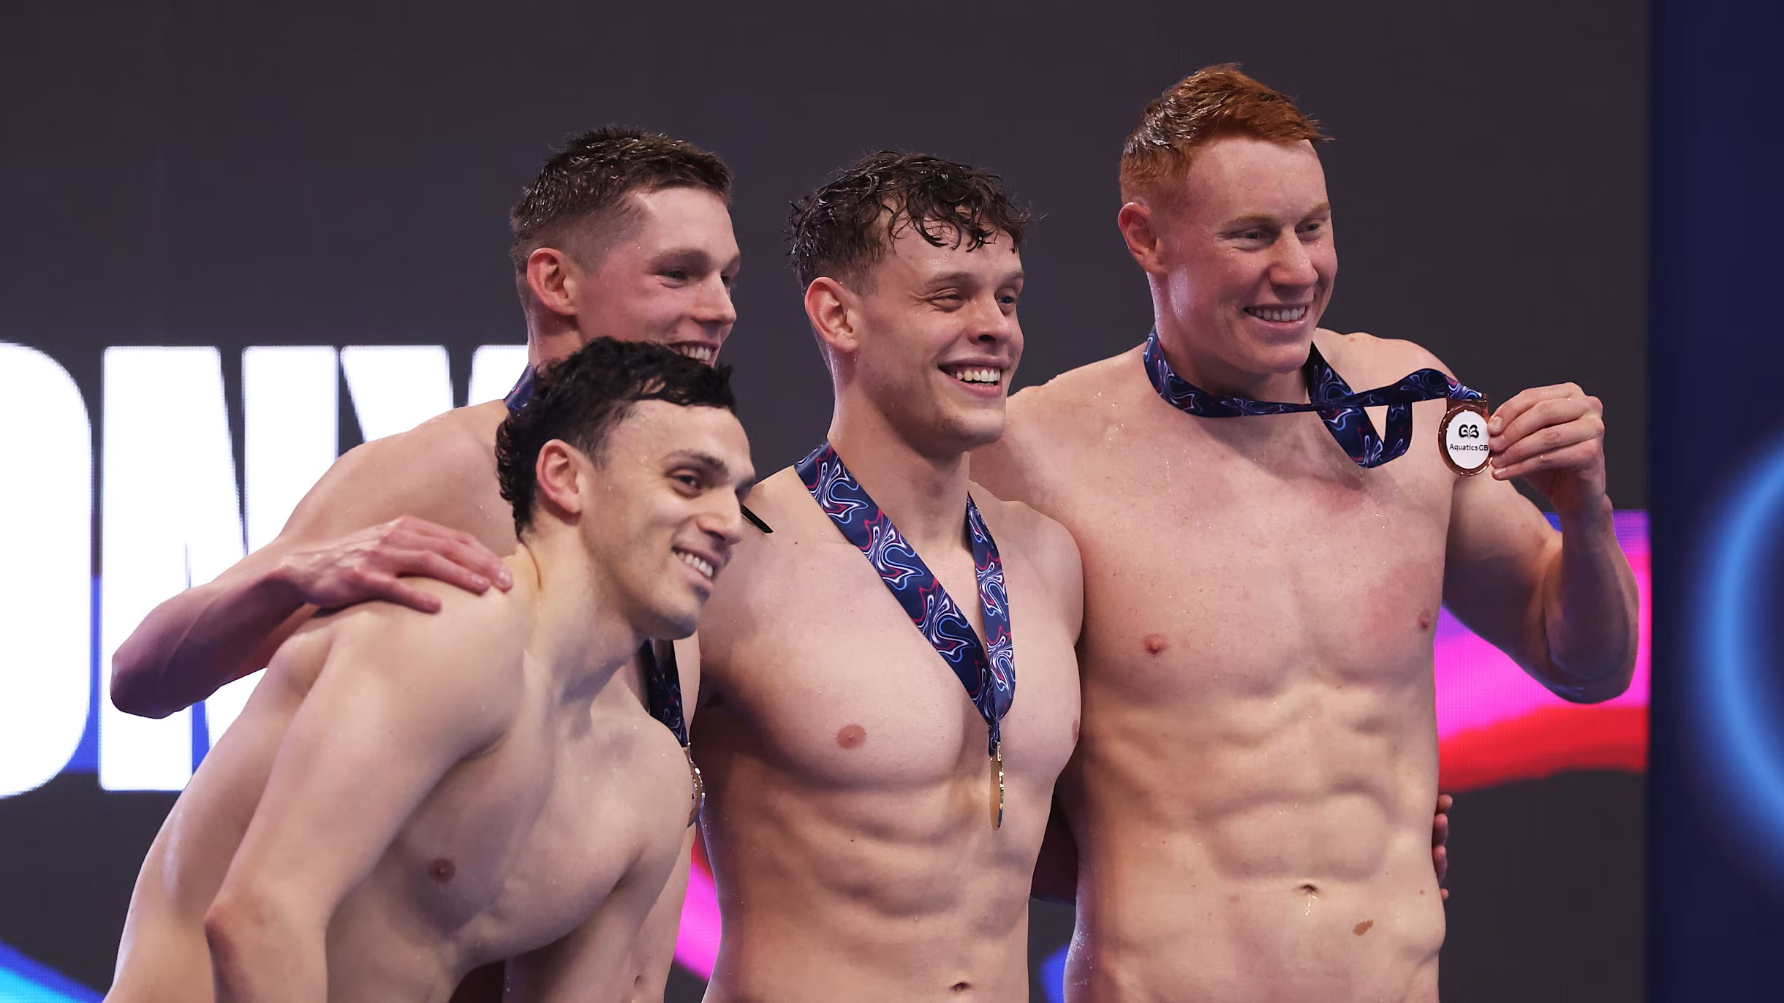Gender diversity at athlete and staff level remains balanced, with a near 50/50 split between female and male members.

Despite progress, our data indicates ongoing underrepresentation in leadership roles and coaching staff for females, disabled people and ethnic diversity. These insights will inform our action plan development for 2025.

|  |  |  |  |  |
| --- | --- | --- | --- | --- |
|  | Census Data (2021) of General Population | British Swimming Survey Results 2022 | British Swimming Survey Results 2023 | Aquatics GB Survey Results 2024 |
| Identify as White (All White Categories) | 81.7% | 92.92% | 87.86% | 85.45% |
| Identify as Non-White (All Non-White Categories) | 18.30% | 6.30% | 9.95% | 8.02% |
| Identify as LGB+ | 3.20% | 4.90% | 6.80% | 5.90% |
| Did not answer question/Prefer not to say (LGB+) | 7.50% | 5.59% | 9.22% | 9.09% |
| Identify as disabled (employees, board and athletes) | 17.7% | 16.08% | 22.82% | 20.46% |
| Employees identified as disabled (Board and employees) | - | 6.94% | 5.63% | 2.35% |
| Religion |  |  |  |  |
| * Christian | 46.20% | 39.16% | 37.04% | 39.84% |
| * No religion | 37.20% | 56.64% | 57.04% | 52.04% |
| * Muslim | 6.5% | 0% | 0% | 0% |
| * Hindu | 1.7% | 0% | 0% | 0% |
| * Judaism | 0.5% | 0% | 0% | 0.74% |

|  |  |  |  |  |
| --- | --- | --- | --- | --- |
| **Which of the following categories best describes you?** | | | |  |
|  | **2021** | **2022** | **2023** | **2024** |
| Employee/Board/Committee Member | 35.14% | 41.96% | 34.47% | 38.64% |
| Athlete – Olympic Swimming | 16.22% | 23.78% | 28.16% | 27.73% |
| Athlete – Diving | 11.49% | 6.99% | 14.56% | 13.18% |
| Athlete – Paralympic Swimming** | N/A | 18.88% | 21.84% | 19.55% |
| Athlete – Artistic Swimming | 8.78% | 0.00% | 0.97% | 0.91% |

**Swimming demographic data was merged for OLY and PLY pre-2022.

|  |  |  |  |
| --- | --- | --- | --- |
| **Race/Ethnicity** | | | |
|  | **2022** | **2023** | **2024** |
| White – English/Welsh/Scottish/Northern Irish/British | 92.92% | 87.86% | 86.08% |
| Mixed or multiple ethnic groups including white and black Caribbean, white and black African, white and Asian | 4.2% | 6.8% | 5.06% |
| Asian or Asian British including Indian, Pakistani, Bangladeshi, Chinese | 0.7% | 0.97% | 0.84% |
| Black, African, Caribbean or Black British | 0.7% | 0.49% | 0.42% |
| Middle Eastern | 0.0% | 0.0% | 0.42% |
| Any Other | 0.7% | 1.46% | 1.27% |
| Prefer not to say | 0.7% | 2.43% | 5.91% |

|  |  |  |  |
| --- | --- | --- | --- |
| **Gender** | | | |
|  | **2022** | **2023** | **2024** |
| Female | 48.25% | 49.51% | 48.52% |
| Male | 51.75% | 50.00% | 49.37% |
| Prefer not to say | 0% | 0.49% | 2.11% |
|  | | |  |

|  |  |  |
| --- | --- | --- |
| **Gender at Leadership Level (Board and Senior Management Team)** | | |
|  | **2023** | **2024** |
| Female | 50.00% | 52.94% |
| Male | 50.00% | 47.06% |

|  |  |  |  |  |
| --- | --- | --- | --- | --- |
| **LGBTQ+** | | | | |
|  | **2021** | **2022** | **2023** | **2024** |
| Bisexual | 2.03% | 0.70% | 1.94% | 1.27% |
| Gay/Lesbian | 0.00% | 2.10% | 4.85% | 4.22% |
| Heterosexual/ Straight | 93.24% | 89.51% | 83.98% | 85.65% |
| Prefer not to say/ Did not answer | 1.35% | 5.59% | 9.22% | 8.44% |
| Other (please specify) | 1.35% | 0.00% | 0.00% | 0.00% |

|  |  |  |  |
| --- | --- | --- | --- |
| **Disability** | | | |
|  | **2022** | **2023** | **2024** |
| Yes, I have a disability (Overall) | 16.08% | 22.82% | 18.99% |
| No, I do not have a disability | 83.92% | 77.18% | 77.64% |
| Yes, I have a disability (Employees) | 6.94% | 5.63% | 2.35% |

